Scope

Maintenance and repair work on electrical installations.

What and how?

Use the principle of the Vital Five!

- Disconnecting
- Locking
- Measuring
- Earthing and short-circuiting
- Cordoning off

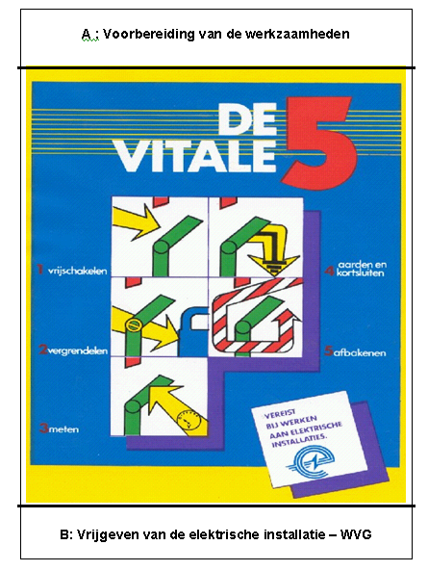

- Disconnecting
Make sure that the installation to be worked on is fully switched off. Interruption is best made visible.

- Locking
Make sure that the installation cannot be switched on again without your permission.

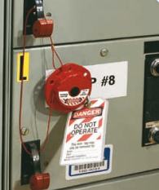

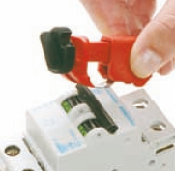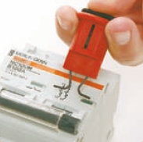

- Measuring
Carry out a voltage test on each conductor forming part of the switched off installation. The result must each time be 0. Make sure that the measuring appliance is designed for this purpose and that the operation of the appliance has been tested before use.

- Earthing and short-circuiting
Earth and short-circuit each conductor in the switched off installation.

- Cordoning off
Apply isolating plates, cloths or other materials to prevent touching live and exposed parts of other installations.

Note
If necessary ensure good consultation between the person in charge of the work and the manager of the installation.

KUWAIT PETROLEUM NORTH WEST EUROPE

DOCUMENT TITLE: The vital 5 when working on electrical installations

DOCUMENT NUMBER: KPNWE.WI.11.HSCO.023

REVIEW NUMBER: 1

EFFECTIVE DATE: 01 Dec 2020

NEXT REVIEW DATE: 01 Dec 2023
..

CONFIDENTIALITY:
The information contained in this document is confidential to Kuwait Petroleum International Ltd. Copyright © Kuwait Petroleum International Ltd. Copying of this document in any format is not permitted without written permission from the management of Kuwait Petroleum International Ltd.

This document is reviewed and approved according to the released online Document Approval Flow

Prepared by: | Operational Assistant | An Cornelis
Reviewed by: | Operational Assistant | An Cornelis
Approved by: | QHSSE Manager | Patrick De Baere

*Access rights: Generally Accessible

Reviews Summary

Review date | Review reference | Review details | Review version
01 Dec 2017 |  |  | 0
01 Dec 2020 | -- | Periodic review - no changes | 1

